Draft Xiaoqingling Gold Mountain Field Trip Report, CASM-China
September 12, 2005

1 Lingbao- an attractive and typical gold rich area of China
The Xiaoqingling Mountain is located at the contiguous area among Henan, Shaanxi and Shanxi provinces, the southeast of famous Qingling Mountain in China. Its core area is in Lingbao city where is a county-level of Sanmen Gorge City in the west of Henan province (see Figure 1). Lingbao is called as ‘a Gold City’ in China, also well-known for its reputations as ‘the Apple Country’ and ‘ the origin of Taoism ’. Lingbao has the total population of 723000 people in 2004 within the area of 3007 square kilometres, covering 10 towns and 7 villages. In 2003 it was approved as China’s excellent tourist city.
By the end of 2004, 24 mining rights have been issued to ASM, occupying 53.3 percent of 45 mining rights in total in Lingbao City. The ASM employees are 1363, mining 317500 Tons of mine ores and realizing product value of RMB 35.98 million, accounting 3.53 percent of total industrial product value in the city. Although there are 7 kinds of minerals, including gold, iron ore, mineral water, cement limestone rock and other building materials, the product value from the gold mining accounted for one third of total ASM.
Over 30 years the Lingbao has contributed over 4200000 Liang (about 7408 ounces) of gold to China and won continuously the second largest gold producing city in the country over 21 years. Its product value in gold industry occupied 80 percent of GDP in the city. In 1996, when the 19 time large-scale rectification in its history, however, hundreds and thousands of peasant workers were repatriated, 358 mine pitheads were closed up and 9023 pieces of small mining equipments were destroyed.
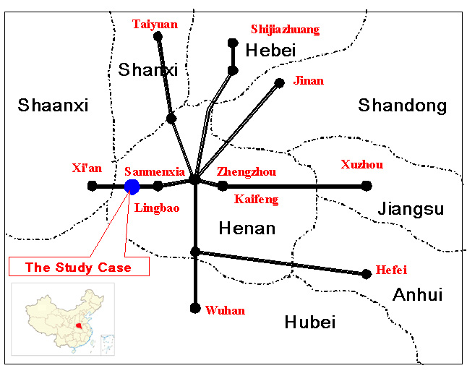
Figure 1 the sketch map on geographic location of Linbao City, Henan province, China

2 Intercommunication, regularization and standardization- a successful ASM regulation model of China
The Xiaoqingling was ever notorious in its illegal ASM in the late 1990s and early 21st century. But now it has become one of the successful cases in the ASM regulation in China. This manifests the following three aspects.
First, its network system established an arena for mutual supplement and intercommunication. This network includes 8 expedited stations as the center, their subordinated stations as the ‘dots’, all mine enterprises as the ‘lines’, and the mining areas as the ‘places’. This cross and intertwining administrative system is linked to local governments, mine enterprises and community residents.
Second, its regularization created a new and efficient management pattern. Up to date it has set up 21 regulation systems, including the uniform signature system for internal administrative affairs, the trace system for administrative faults, the dynamic visitatorial system for the supervision of executing the laws. It formed the mutual supervision of the Geological Bureau and the stations, the declare system of mine ore allocations and transports for enterprises, and the monthly report system all the time by which each truck has at least one card and one list indicating its allocating and transporting ores and its daily records.
Third, its standardization started up all-round function transformation in mineral administration. The Geological Bureau of Lingbao City changed its fully stopping approach into the combination of both leading and stopping administration thus ensuring the formation of mining supervision in beforehand, midway and afterwards procedures. The beforehand supervision requires strict justifications, application procedures, materials and registrations and approvals for mining rights. The midway supervision combined the approval of allocations and transports of mineral products with the control of enterprise overproductions. The afterwards administration supervised and urged mining rights owners to carry out related procedures in the bankruptcy, ownership transformation, closure and stoppage of mines.

3 Gold resource consolidation- an effective and efficient ASM strategy
By consolidation, the gold industry in Lingbao city created a successful model for the ASM regulation management of other areas in China. This consolidation was carried out according to three steps below: first, 8 local state-owned gold mines were consolidated into three major companies, namely, Lingbao Gold Joint-Stock Company, Jinyuan Mining Limited Company and Lingbao Gold Investment Limited Company, three of which occupied 75 percent gold proven reserves in the Xiaoqingling Moutain area; second, all town and village ownership gold mines were gradually merged into different kinds of enterprises (see more details afterwards); third, different ownerships of enterprises were reorganized by ways of mergers and requisitions. It is well manifested by the case of Shuangxin Gold Ltd. Company in Yuling Town. The Shuangxin company was established by the shares of 55 percent from the Wenyu Gold Mine- an old state-owned large mine of China, 40 percent from Mr. Guo Gold Mine- a small-scale gold mine, and 5 percent from Henan Gold Company – a province-level of gold administration. The Shuangxin was considered the first united gold enterprise by the large- and small-scale mines in China.
For the second case mentioned above, most enterprises were transformed by the town and village ownership gold mines (see table 1). Almost all those small-scale gold mines realized integrated development by way of consolidation and won great benefits in terms of either socio-economic or resources and environmental indexes. Mr. Guo Xiaohong (see Figure 2), for example, could not but be mentioned here.
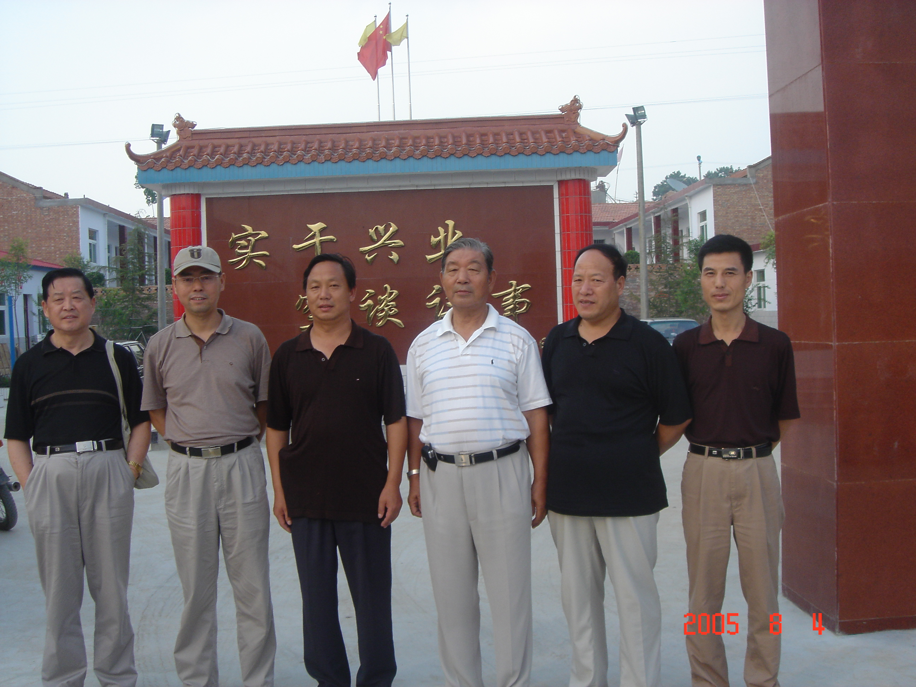
Figure 1 Mr. Guo Xiaohong (the third from left) is joining the group photo with CASM-China

Mr. Guo was purely peasant before 1992. Owing to the gold mining, he was become the rich man in his Chengcun village in the late 1990s. In 2004, he contracted with a bankrupt state-owned gold enterprise and provided 200 workers employment except turning in RMB 5 million deposits to previous enterprise annually. In addition, he ran another gold concentrating mill and a comprehensive farmland. Some recreational activities like fishing and tourism are also in progress.
In Chengcun village of Lingbao City, Mr. Guo is playing a leading role in improving rural infrastructure and helping poverty reduction. As an example of Mr. Guo, other people such as Zhao Ziyi, Zhang Jude and Guo Shanshui also ran their own entities. As a result, the city realized profits of 239 million RMB Yuan(about US$29 million) in 2004, increasing 36.5 percent than that before mine consolidations, producing 530000 Liang annually (about 935 ounces ).
Table 1 Several typical ASM transformation cases in Lingbao City, Henan Province, China
Initiator | Name of the enterprise | Date of establishing | Investment  (RMB Yuan) | Scales | Benefits
Mr. Guo Xiaohong | Ore Concentrating Mill of Changhong Wells and Lanes Company | March 2005 | 12 million | Its design scale is the processing capacity of 200 Tons daily within the area of 21000 square meters, including the building area of 3900 square meters, 5 big transport trucks and 2 loading machines. | It is estimated to create annual product value of RMB Yuan 30 million and profits of RMB Yuan 2.8 million, to provide 300 peasants for fixed employment. It will also rebuild 3 kilometers village road for local people.
Mr. Guo Xiaohong | Chengcun West Comprehensive Farmland Development | 1992 | 1.2 million | A wild ravine has been developed into a comprehensive farmland since 1992, planting 8.7 hectares for apple trees, 1.3 hectares for peach trees, 1.3 hectares for almond trees, 1.3 hectares for pear trees, 4 hectares for fast growing poplar trees, 1.3 hectares for vegetable field.  A hoggery was built within the farmland, raising 42 sows and 200 commercial pigs. | About 600 pigs could be sold out annually. The pig manure pit provided 5 stations of methane pools with the capacity of 10 cubic meters. The pools are linked by tunnels for concentrated gas feeding. A one kilometer road was rebuilt with hard surface.  In addition, 7 standard sheds will be built for 0.34 hectares vegetable planting. 4 pools will be cultivated for fish feeding and several pavilions and towers will be built for recreational fishing.
Mr. Zhao Ziyi | The Second Mill of Ore Concentrating Experiment | 2001 | 6.5 million | Its design scale is the processing capacity of 150 Tons daily with 2 pits mining 120 Tons gold ore daily. | It arranged over 40 peasants employment and paid RMB Yuan 400000 profit to the State per year.
Mr. Zhang Jude | The First Mill of Ore Concentrating Experiment | 2000 | 8 million | It sets up one concentrating mill and three pits with the capacity of 250 Tons daily | It created the product value of RMB Yuan 20 million and profits of RMB Yuan 2.6 million, arranged 60 peasants employment. It mainly processed low-grade gold ore at less than 3 gram per Ton.
Mr. Guo Shanshui | The iron Powder Agglomeration Mill of Sanlian Company | August 2004 | 8.9 million | It sets up one concentrating mill of iron ores with the capacity of 200 Tons iron ores and 80 Tons iron powder daily. All iron powders are further processed into the ball iron products with the capacity of 100 Tons daily. | It created the product value of RMB Yuan 26 million and profits of RMB Yuan 3 million, arranged over 100 peasants employment. Its added values from iron powders into ball iron products increased RMB Yuan 120 per Ton.
Source: according to authors’ interview on 28 July to 6 August 2005 in Lingbao City of Henan Province, China.

Liang is a unit of weight and equal to 0.05kg.

